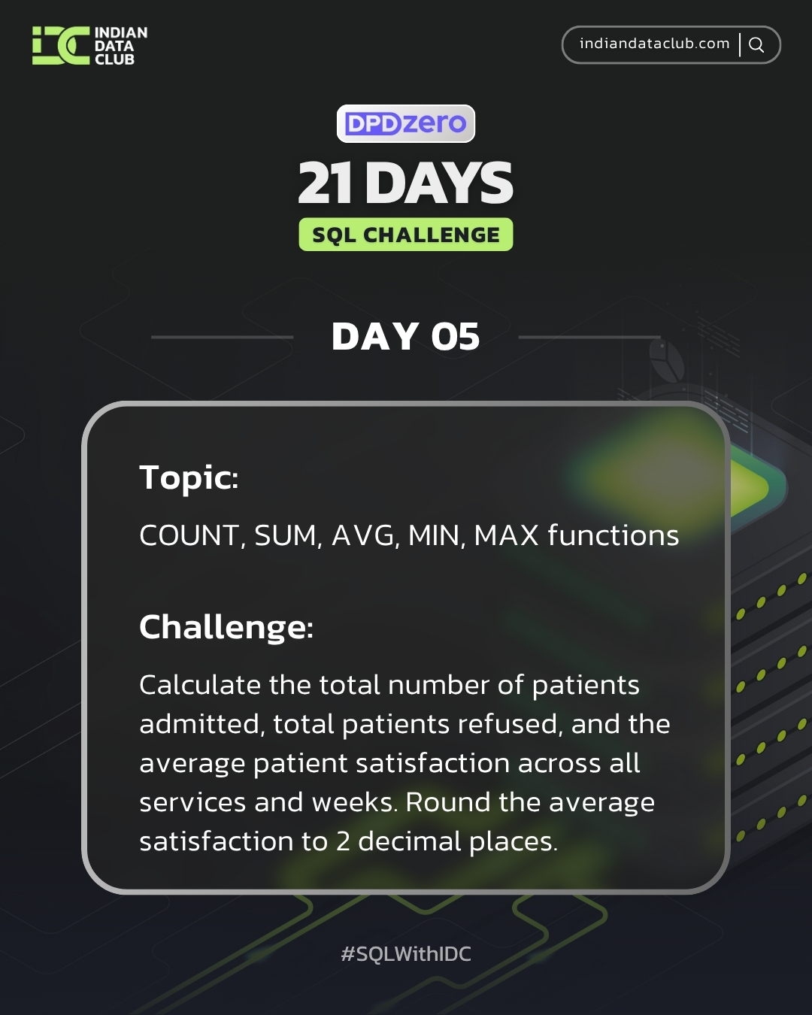

Day-5 SQL Challenge
Day-5 Challenge:
Calculate the total number of patients admitted, total patients refused, and the average patient satisfaction across all services and weeks. Round the average satisfaction to 2 decimal places.
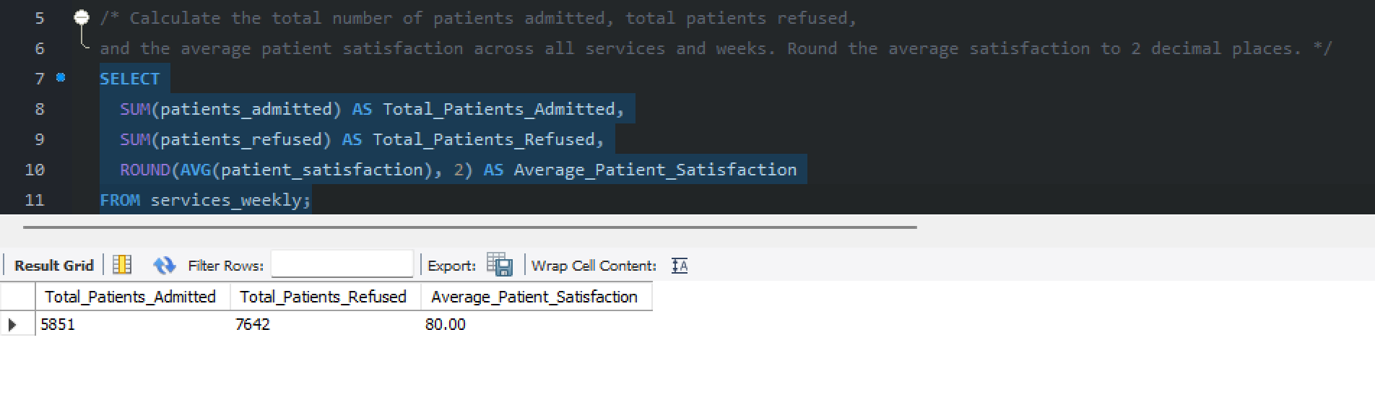
Practice Questions:
1.Count the total number of patients in the hospital.
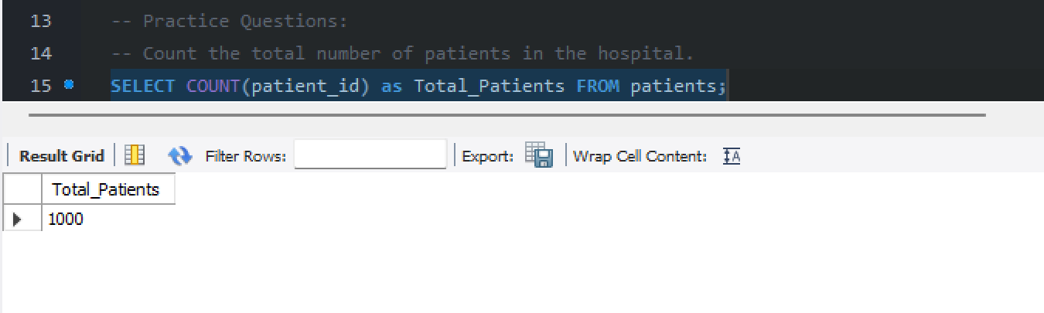
2. Calculate the average satisfaction score of all patients.
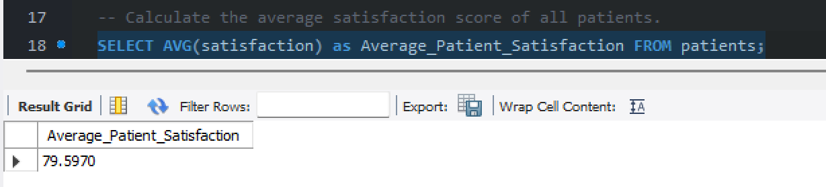
3. Find the minimum and maximum age of patients.
